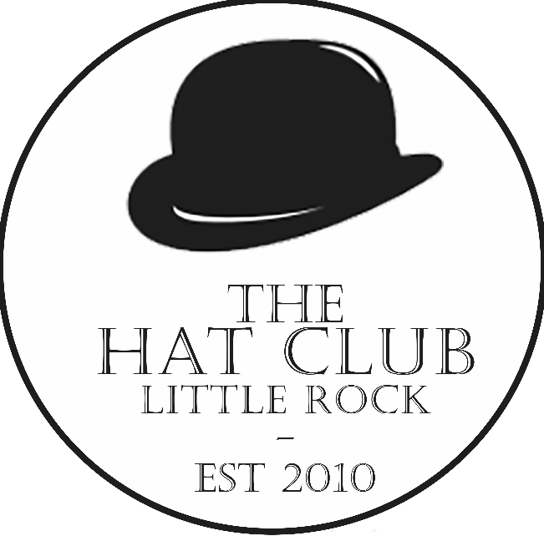
Hat Club New Member Application
Little Rock, AR www.hatclublr.com Tax ID # 27-2390129

Our Mission
The Hat Club is a socially responsible non-profit organization that provides its members with an opportunity to engage in networking and meaningful community service activities.
The primary function of The Hat Club is to plan fundraising events in support of reputable charitable organizations looking to achieve long term stability. Through our activities, The Hat Club will not only benefit these organizations, but the community.

Organization
President: Eric Elizondo
Vice President: A.J. Reynolds
Treasurer: Cameron Fuller
Secretary: Jake Logan
Membership Chair: Kyle Schnebelen

Board of Directors
Chad Brown
Erik Mitchell
Ben Vigurie
John Kincannon
JR Bizzell

New Member Requirements
We look for members that are committed to adding value to the organization while giving back to the community. We want new members that intend to be involved from the beginning, and we choose our new members with these goals in mind. We are only accepting 40 new applications this year and only the best of the best will be granted a membership.
ALL NEW MEMBERS MUST COME TO THE MEETING ON FEB. 3RD, 2024.

- Actively participate on one event committee per year

Attend at least 50% of committee meetings OR be responsible for a minimum of $1,000 in donations/sales towards the events.
- Actively communicate with assigned team leader for all meetings and events
- Attend at least one (1) club wide event or team gathering.

Must meet all requirements by January 1, 2025.

Any member not fulfilling ALL the requirements above could have their membership revoked.
*Meetings/Social Gatherings will be held every month or as needed.
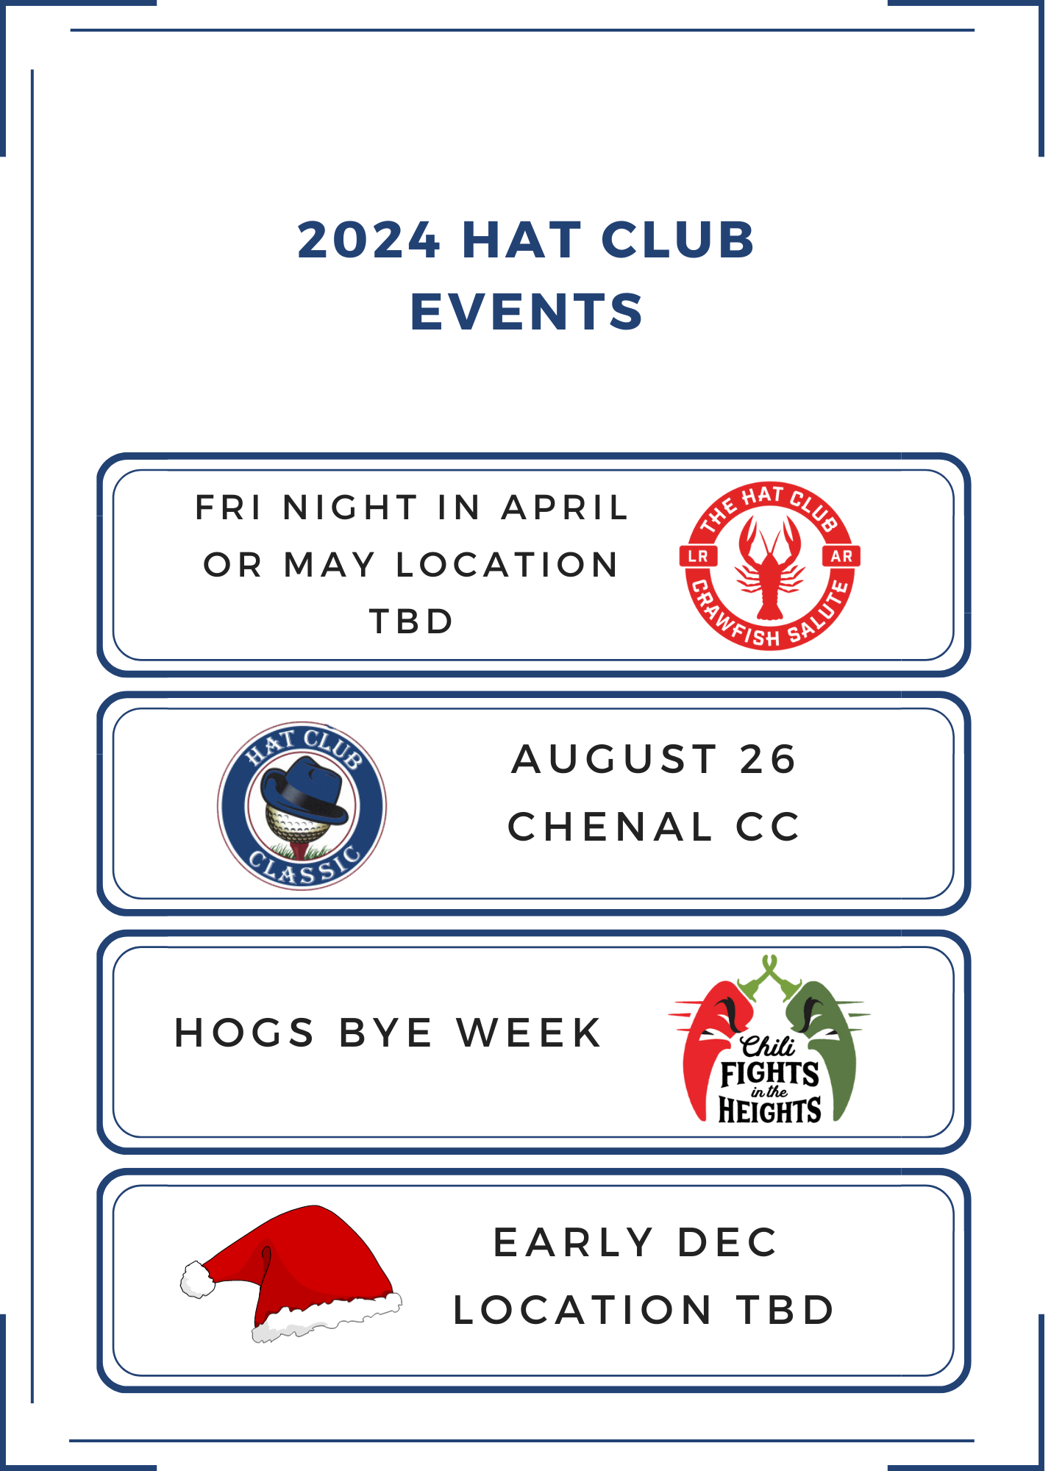

New Member Contact:
Kyle Schnebelen
kyles@cp-ins.com
5018315221

Applicant Information
First Name | Last Name
Street Address |  | Hometown
City | State
Phone | Email (*most frequently used)
How did you hear about the Hat Club?
College (if attended)
Current Employment
Hat Club Member Reference | Relationship | Phone or Email
Hat Club Member Reference | Relationship | Phone or Email
Community Reference | Relationship | Phone or Email
Past Community Service Experience
How much weekly time do you have available to volunteer with the Hat Club?

If you could invite three guests (living or dead) to dinner, who would they be and why?
Have you ever attended a Hat Club event? If yes, what event?

What could you do to contribute or add value to that event? OR how might you change it?
What is your proudest achievement?
If you had the opportunity to create a new event for The Hat Club, what would it be?
Are you comfortable approaching companies on our behalf to attempt to sell golf teams, tables, and sponsorships?

Let me hear your best joke.
More than anything else, what do you want to get out of your Hat Club membership?

